**Kalboard 360 Learning Management System Report**

**Kalboard 360 is a multi-agent LMS, which has been designed to facilitate learning through the use of leading-edge technology. This technology was used to teach a sample of students from the University of Jordan over the span of two semesters. Their test results were recorded, as well as many other variables, and created into an educational dataset.**

**In this report, we try to analyze, identify, and explain some of the factors that most heavily influence the students in the highest, middle, and lowest grade groups. These groups are defined as lowest (0-69% grade), middle (70%-89% grade), and high (90%+ grade).**

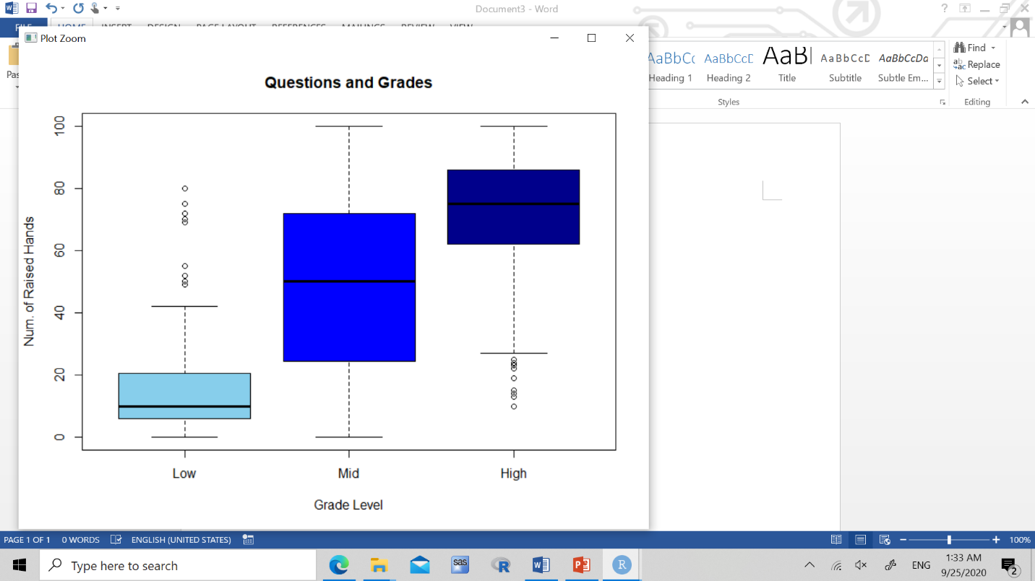

***Figure 1: We can see that viewing resources given in class affects grades quite a bit, with a few outliers here and there. There is a very large spread for mid-grade level(70-89), indicating that raising your hand more in classes will separate you from the lower grade groups. The spread in the higher group also shows that asking more questions will help to get you higher grades, as shown from the differences from the other groups.***

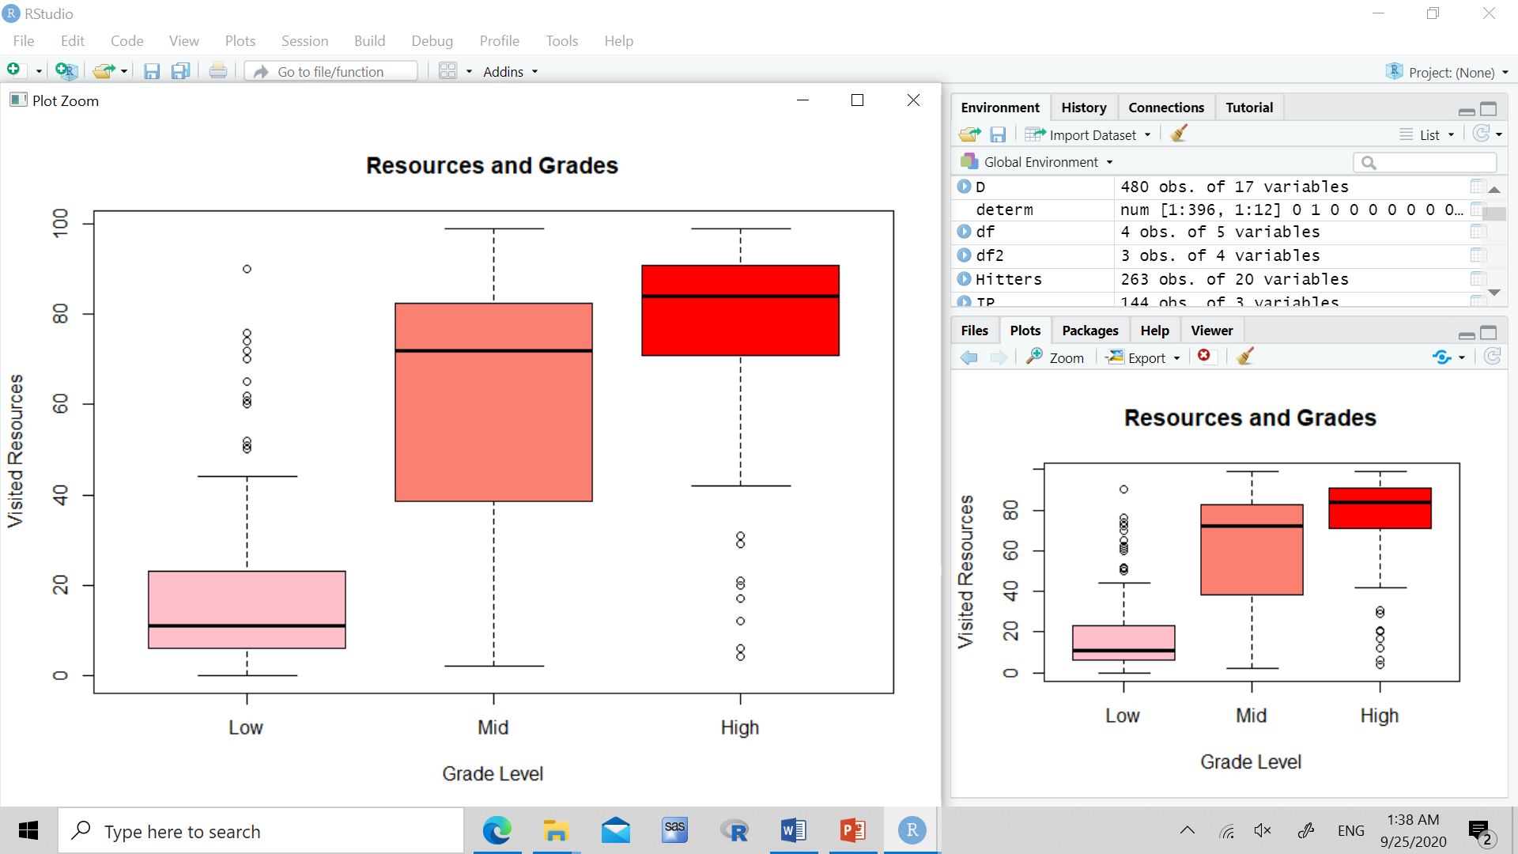

***Figure 2: We can see that viewing resources given in class affects grades quite a bit, with a few outliers here and there. There is a very big spread in the mid-level grade group compared to how little resources the low group visits, meaning that resources plays a big part in separating mid and low level graded groups. The majority higher graded groups have all visited at least 40-100 of the given resources, a much higher number then the other two groups.***

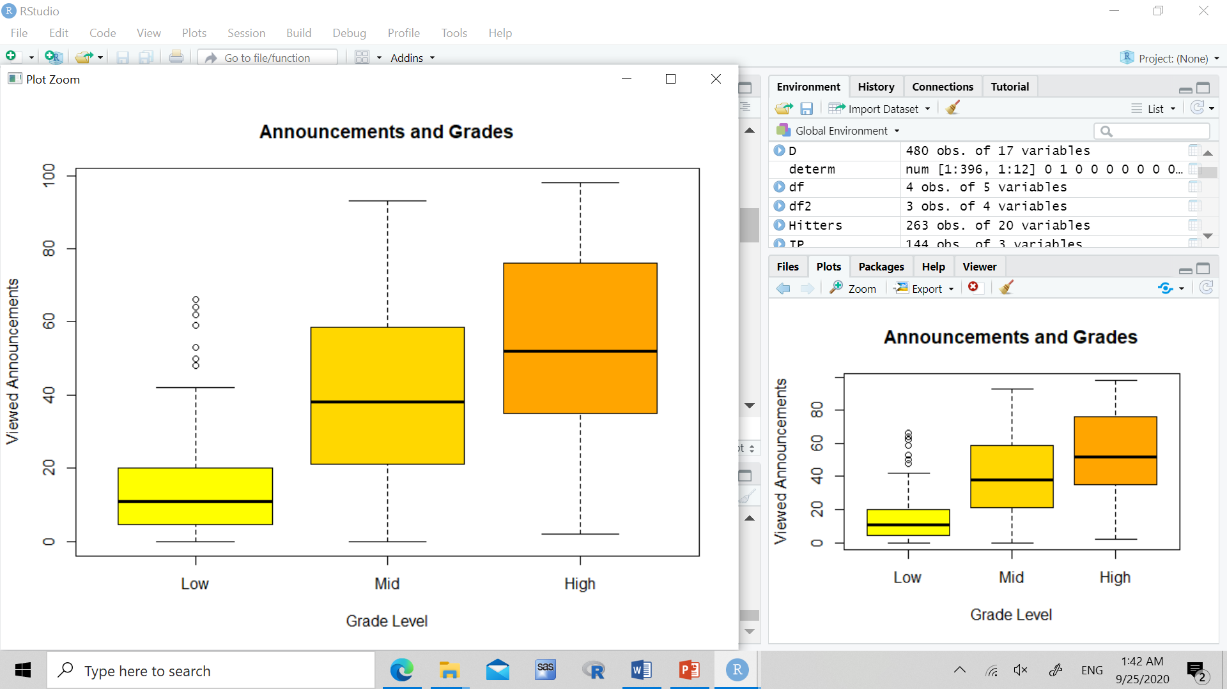

***Figure 3: We can see that viewing announcements matters, but not as much as the other factors. There is a clear separation from the lower groups, but not as much between the mid and higher groups.***

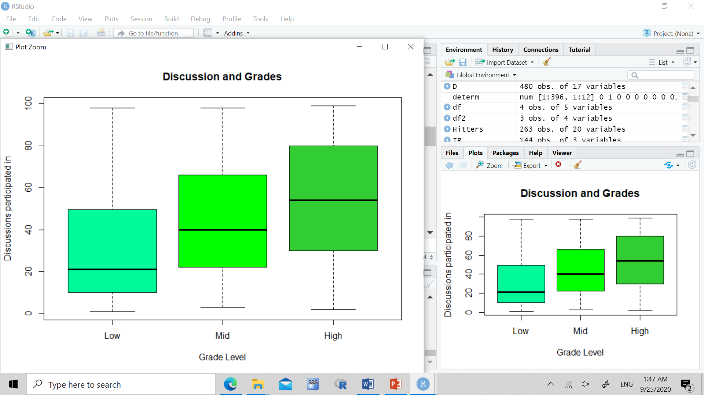

***Figure 4: There is a shift between groups when it comes to discussions, showing a separation from the lower groups, middle and higher groups, although not as strong of a factor as asking questions and using resources.***

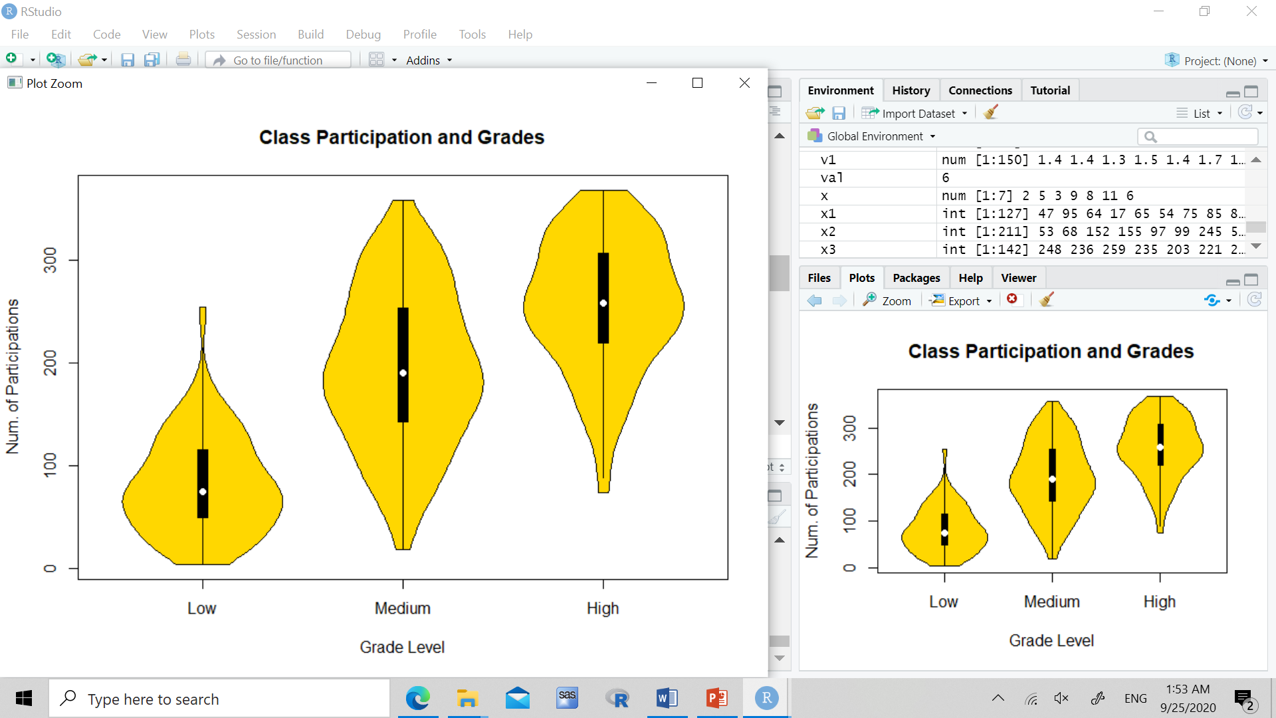

***Figure 5: We sum the values of discussion, viewing resources and announcements, and asking questions to get a participation statistic for each student. Now we can see from the violin plot, the clear spread and cluster of where the average student in each group should be, based on their amount of participation in the class.***

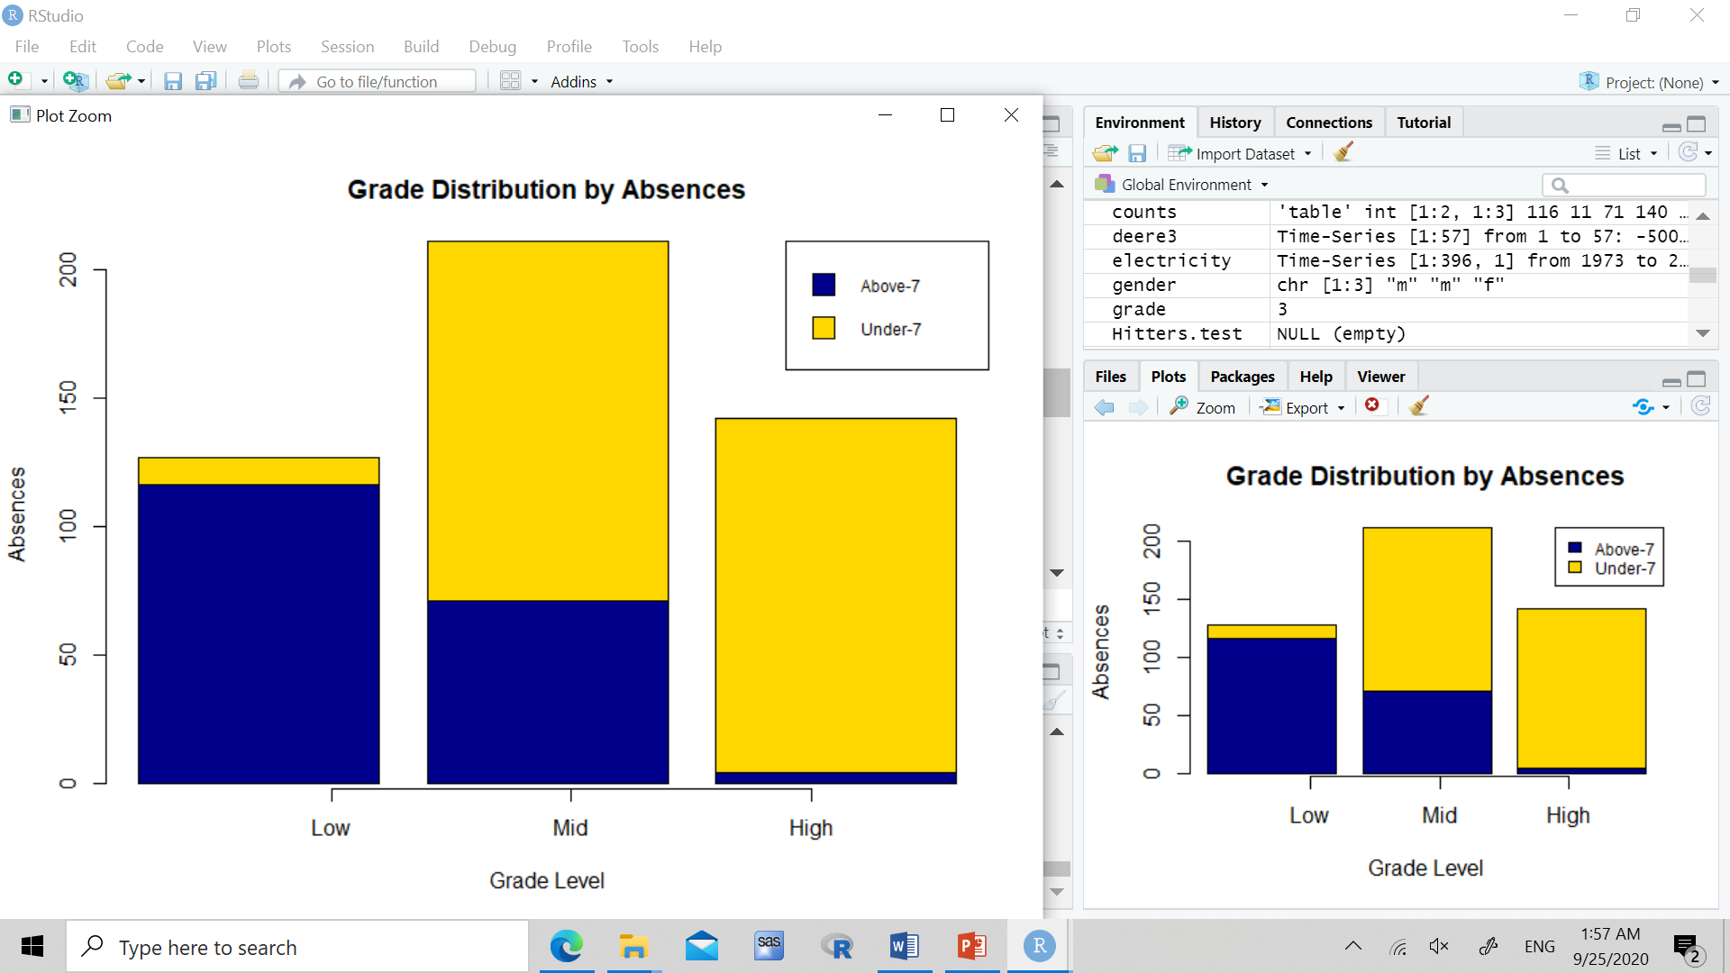

***Figure 6: We see a very high trend in the low and high groups in attendance, where almost all of the students in the lower grade group have missed more than 7 classes in the semester, where as an even higher percentage of the students from the higher grade group have missed less than 7 classes all semester.***

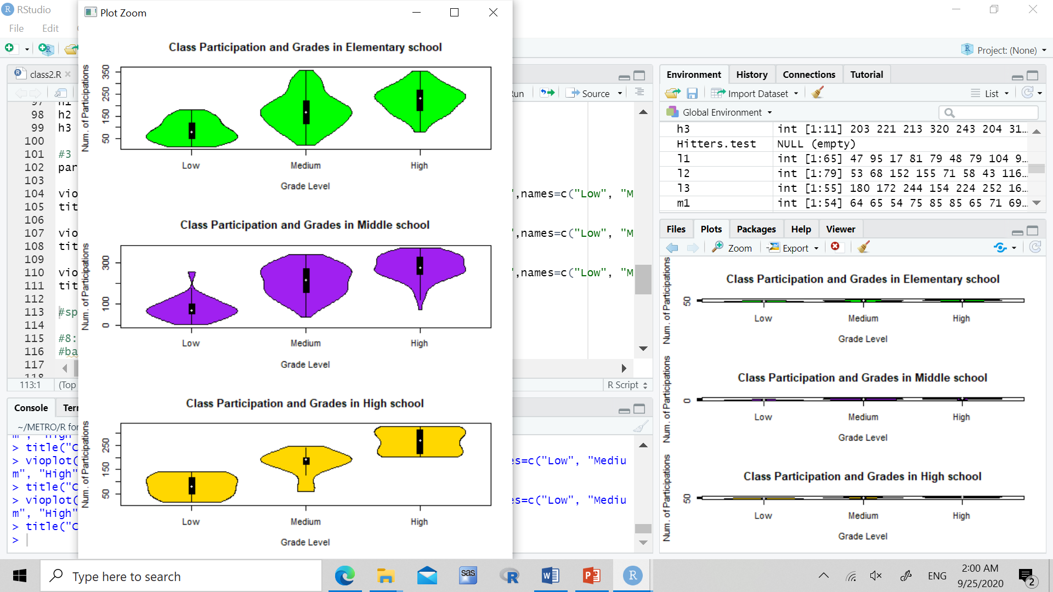

***Figure 7: We are shown from this graph that in elementary school, there is a large variation of participation, where someone attending half of all participations could be in any one of the grade groups. In middle school, the spread tends to narrow a bit more. In high school, participation matters a lot, where there is a clear range of participations from students at every grade level.***

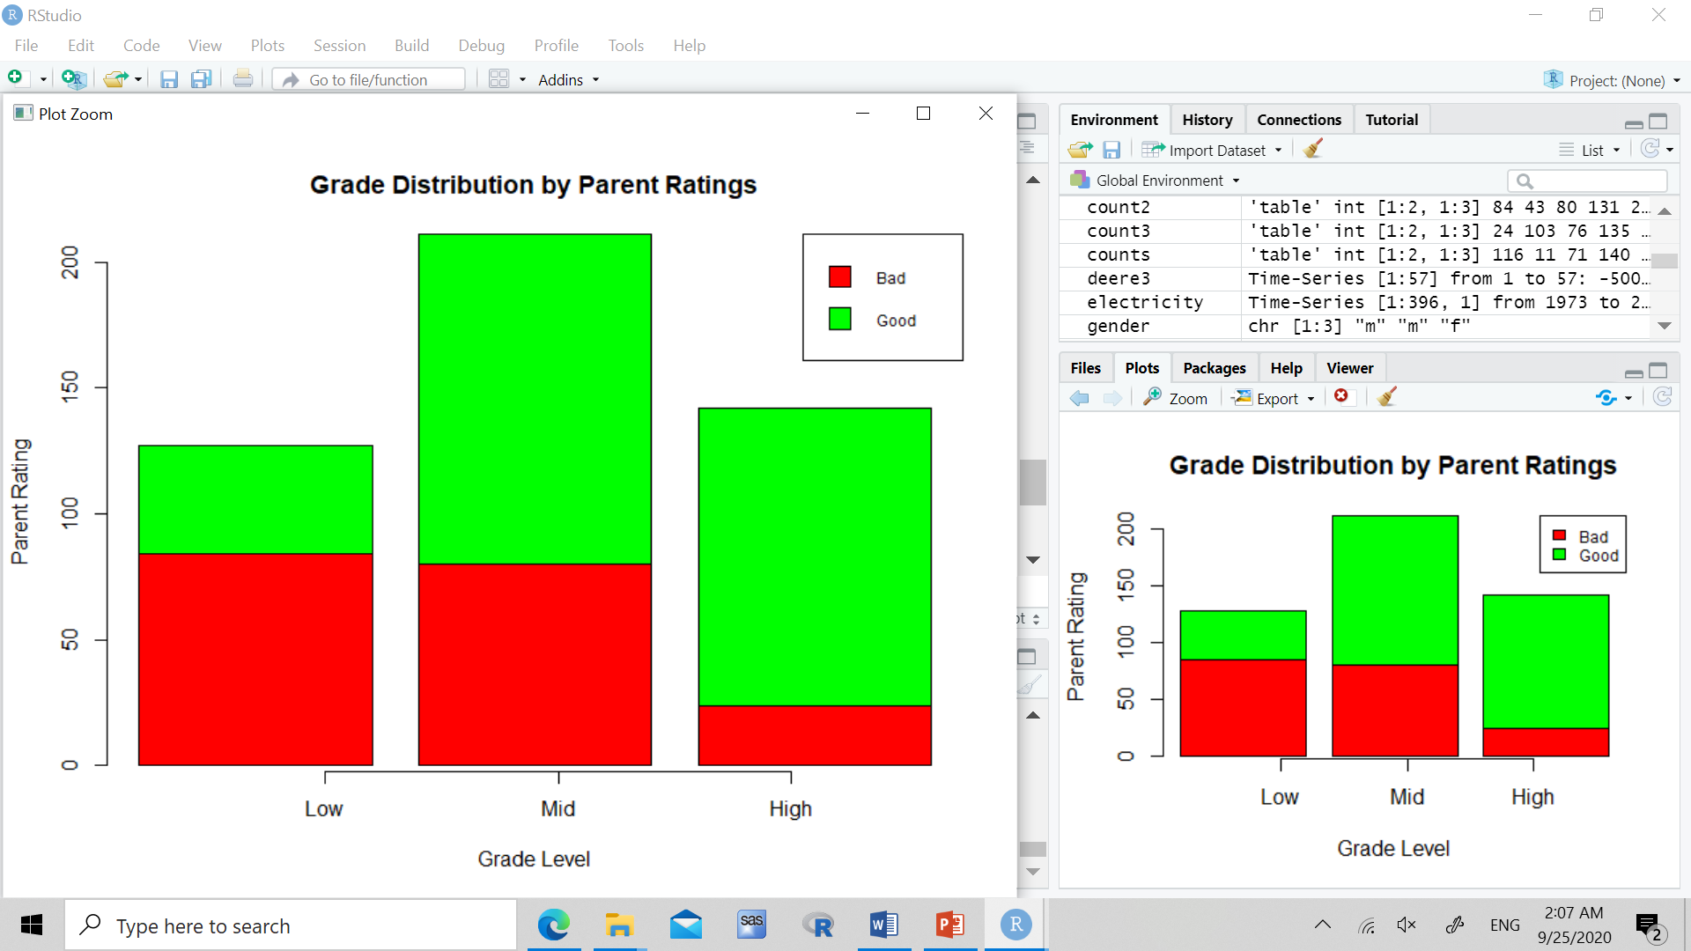

***Figure 8: Parents ratings seems to not be a cause of the grade groups, but an outcome. When the students’ grades are lower, there seems to be a higher percentage of parents from that group giving a bad rating, and when they have higher grades, there are more parents from that group giving good ratings.***

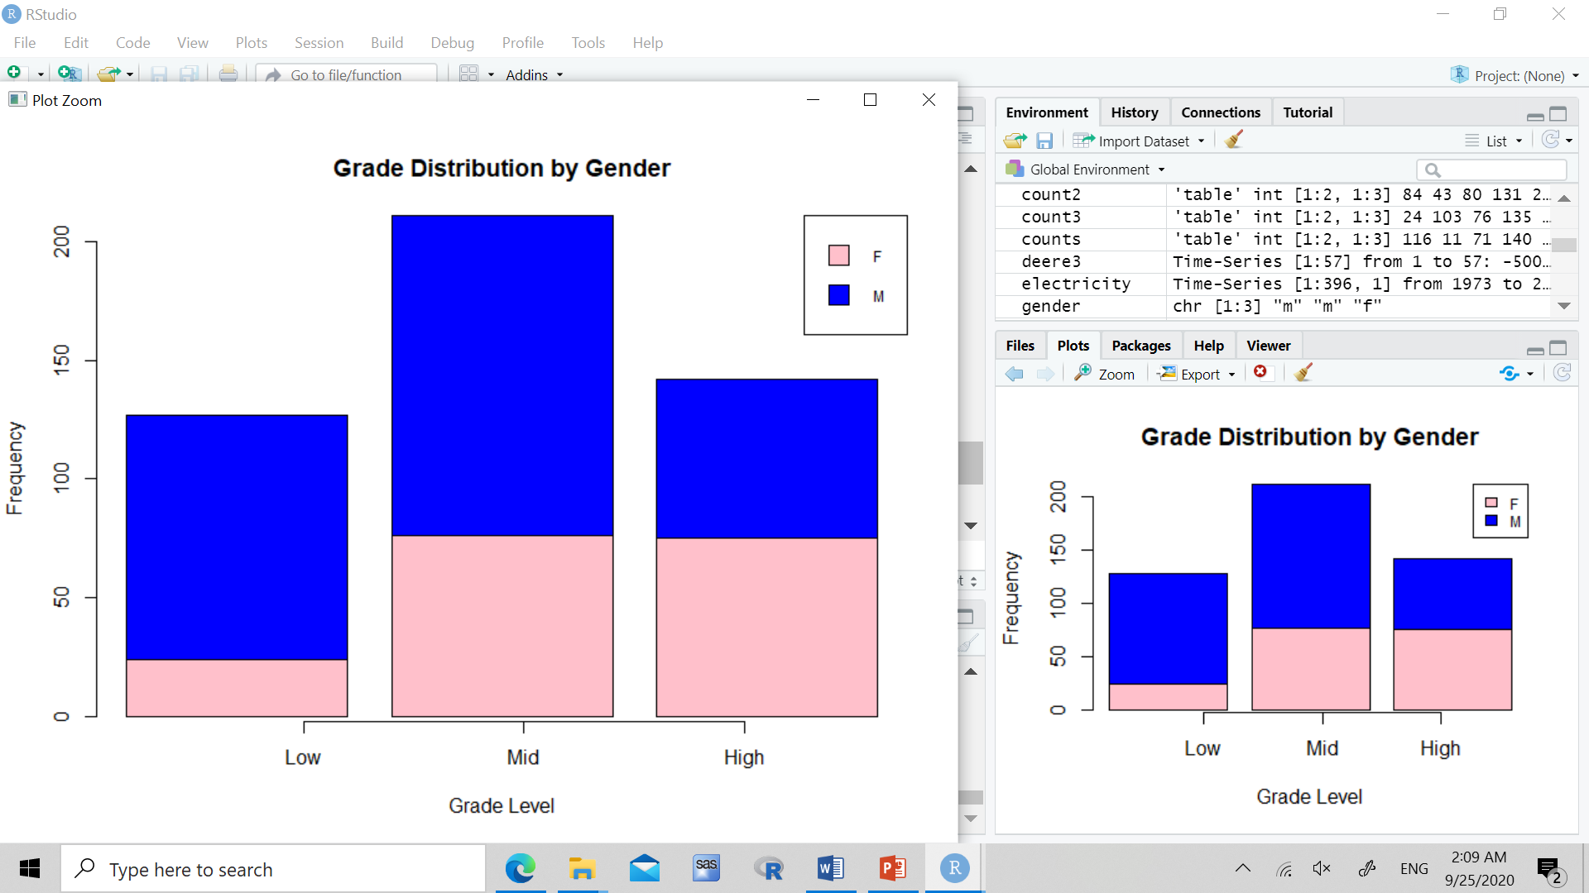

***Figure 9: We are shown that there are not only more boys in the school, but that boys make up the majority in both the low grade and middle graded groups. There are significantly less girls in the lower graded group compared to boys, and slightly more girls than boys in the higher grade group.***

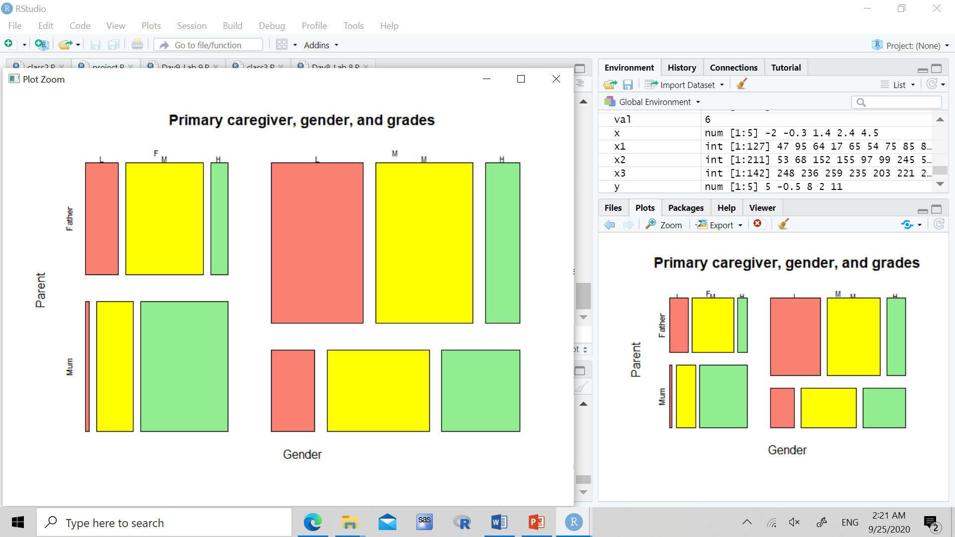

***Figure 10: We are shown some weird trends in this graph. We are given a proportions plot of the groups, separated by primary parent and gender. It seems as if the moms that take care of there daughters have very high success, with almost none in the low grade group, and over half in the highest graded group. Also, it seems the opposite with fathers that help their boys study, with a bigger portion of their sons in the lower and middle graded group, and less in the high graded group. It seems like the mothers that are the primary parent have more success with more children in the high graded group.***

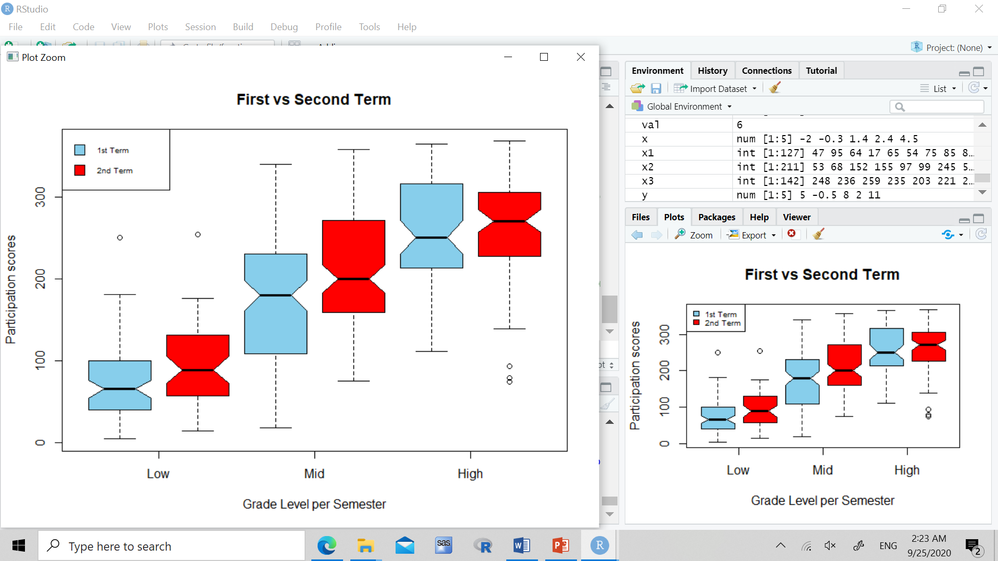

***Figure 11: Here we compare the first and second term participation scores for all groups. There seems to be a trend in the low and middle groups, where they tried to participate more in the second semester, so they could try to improve their marks perhaps. The higher graded group’s participation increased a little, while some decreased, but for the most part stayed the same.***